**Data**

Counts were normalised by the variance stabilising transformation in the DESeq2 R package. The full list of 5254 genes was taken and some very minimal trimming down to 5003 genes (count >10 for at least two samples, and variance > 0.05 across all samples).

**PCA**

The scree plot shows an ‘elbow’ at possibly 4 or 6 or even somewhere up to about 10 (after which variance explained plateaus at a relatively low level). That said, the drop-off over the first few components is considerable e.g. PC1 describes several times the amount of variation in the data than even PC2, but PC5 and PC6 are very similar.

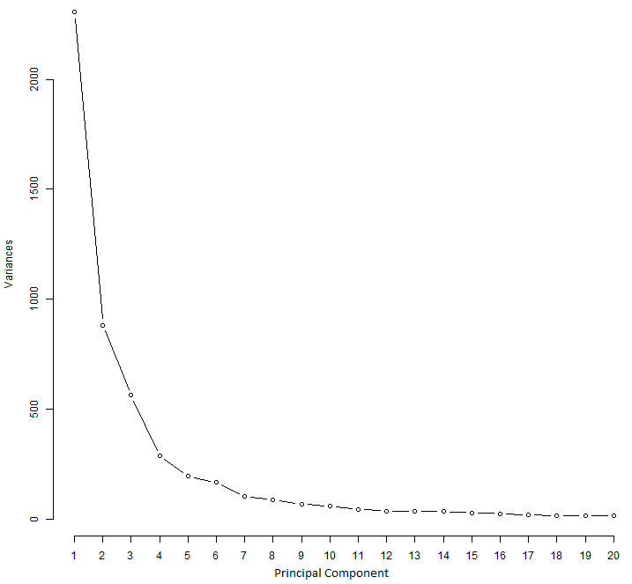

The main things we can see from the PCA analysis are that the WT stages generally cluster tightly together (with WT.16.3 and the WT.16 cluster in general being a little off), and that the cells mature along the axis of PC1, which contains most of the variation in the dataset. The KO gametocytes cluster closely with themselves and with the WT gametocytes. The KO ookinetes don't progress as far along the PC1/development timeline, but it is difficult to say that a certain KO group is most similar to a particular WT group since the KO ookinetes are quite different from each other, much moreso than the WT ookinetes. PC2 separates 8hr ookinetes from the other WT groups.

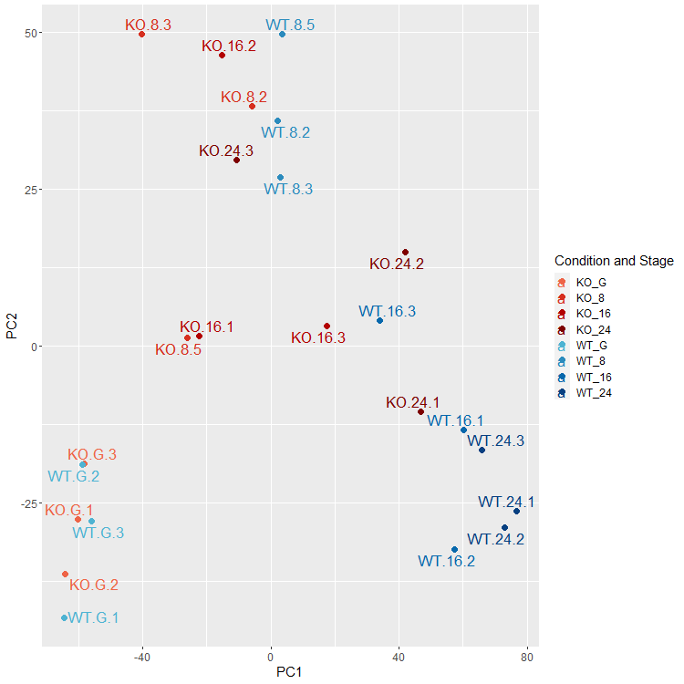

Constricting the input gene list to the top e.g. 1000 genes by variance could potentially change the results by removing noise and other unwanted variation. However in this case the results are much the same: the WT stages are progressing in timepoints as you progress along PC1, and the KO are very similar at gametocyte stage but less so later on. WT.16.3 maintains its position between the other 16hr samples and the 8hr group.

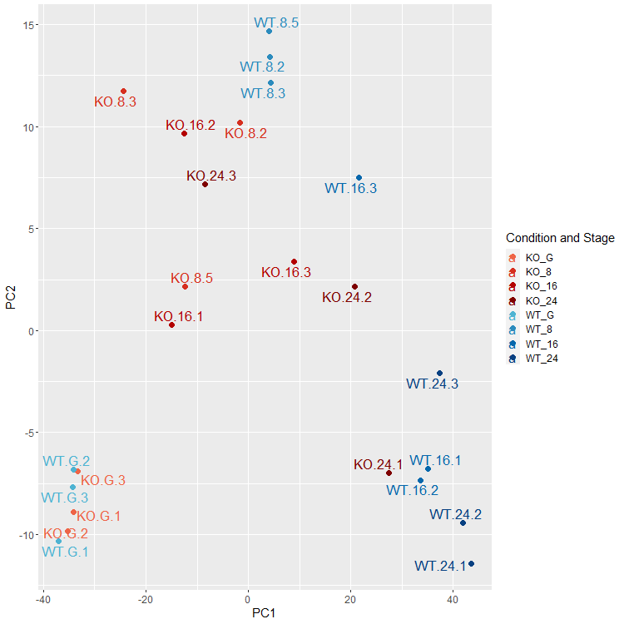

PC3 and PC4 combined give a good separation of the WT and KO samples, and some clustering of the timepoint subgroups appears to occur. Again WT.16.3 clustering with the 8hr WT subgroup.

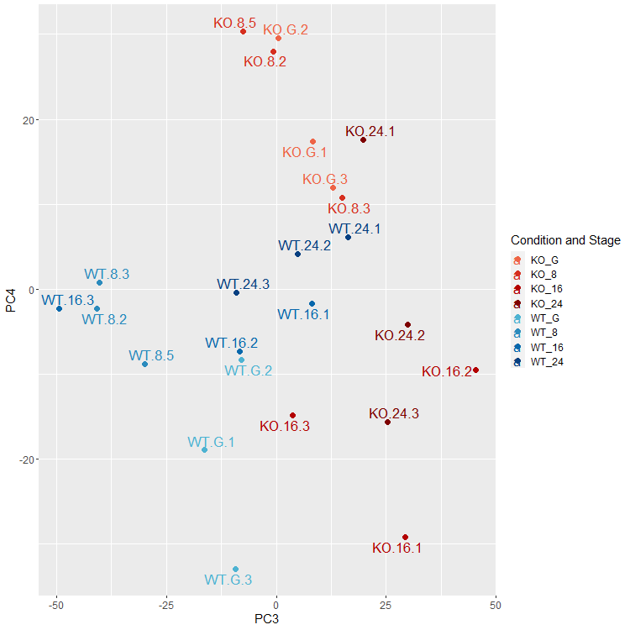

This is the first 10 PCs, with each sample plotted in just one dimension at a time, which may be easier to look at. It gets hectic later on, but it probably isn’t really required - I can produce those properly with all sample ids shown if you like though. (Larger version available in folder.)

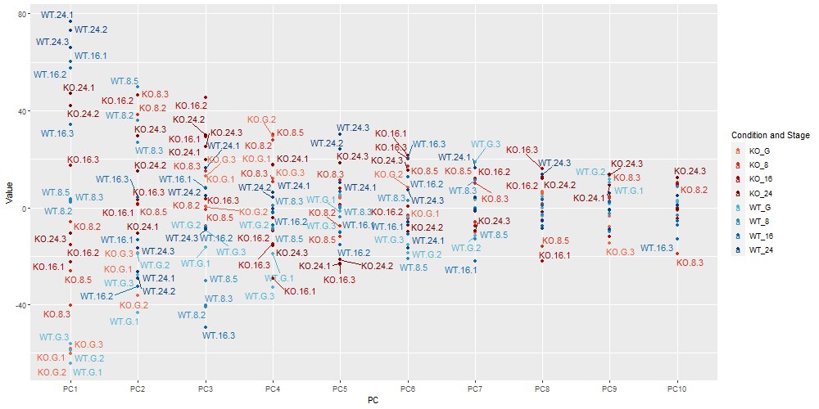

**Hierarchical Clustering**

Again all WT timepoints clustering together except WT.16.3 which instead clusters with the 8hr WT group. Again the KO gametophytes are closely clustered with themselves and with the WT gametophytes. Again the KO samples are a bit dispersed.

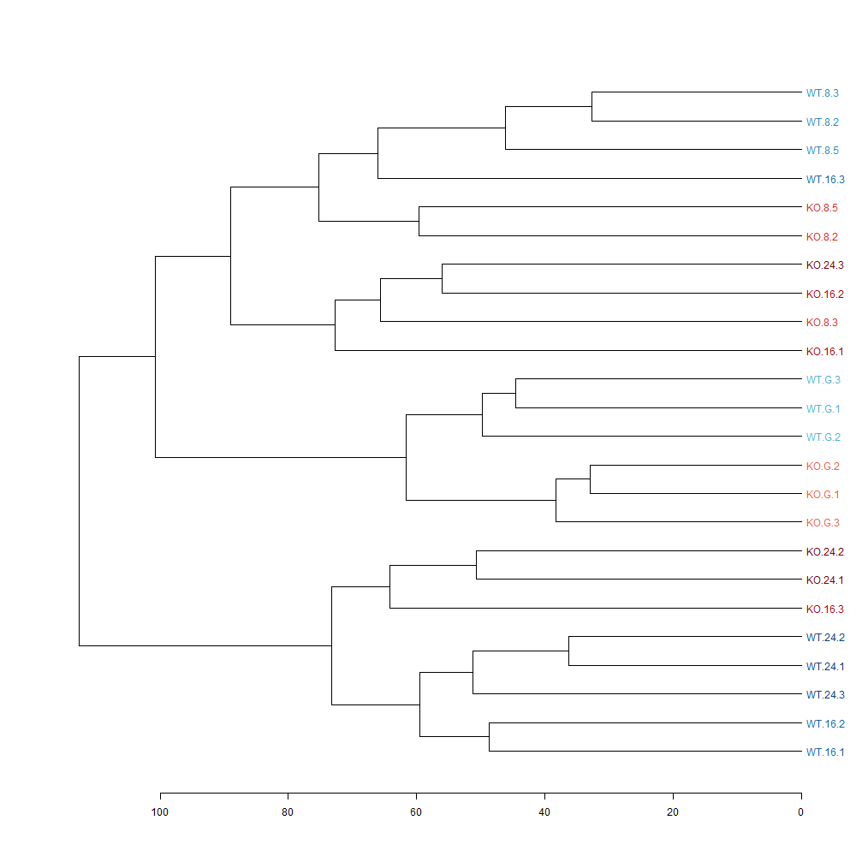

Again looking at the top 1000 genes by variance and get a mostly similar result.

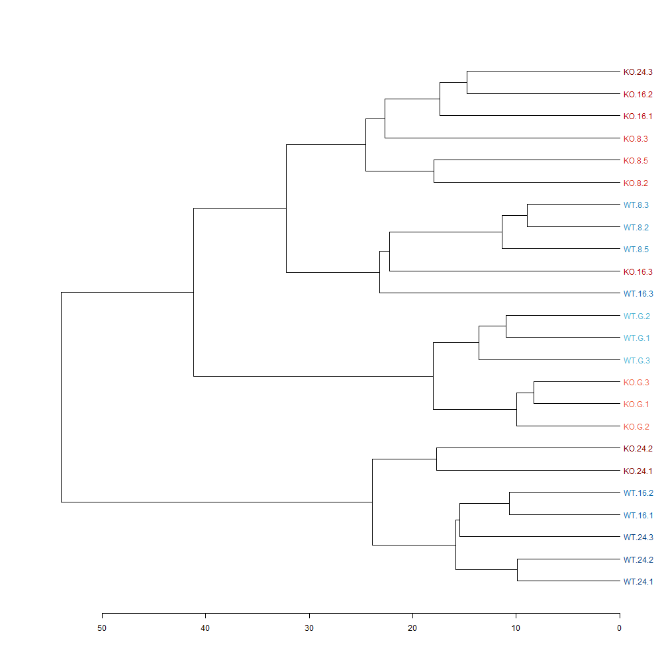

**Multiple Linear Regression**

Multiple linear modeling was used to compare each KO sample against all of the WT stages in context with each other, and it shows a number of negative relationships that might not be expected from simple linear regressions and correlations. This could also be because parts of the variation which form the main positive relationship have already been described by another coefficient. Generally-speaking since the WT timepoints are highly correlated this indicates an issue called multicolinearity, meaning the results may not be very reliable various ways. Because of this and the fact that adding multiple timepoints into a statisical model does not model any real world situation, pairwise comparisons are perhaps better in this case despite using less information.

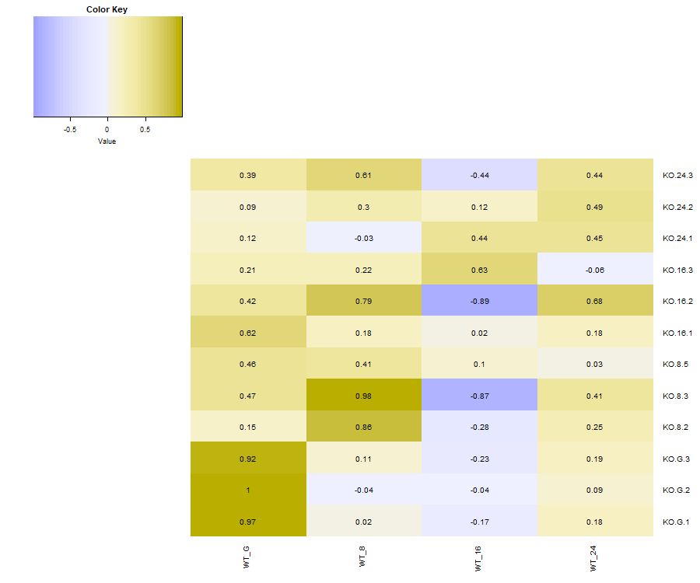

Alternative fig:

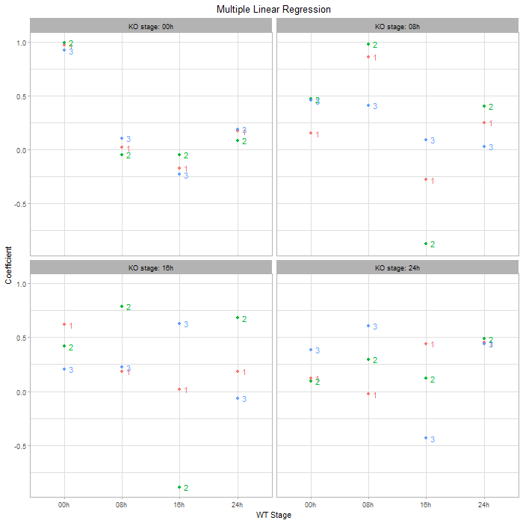

**Correlation**

Simple linear regression, as an alternative to multiple linear regression, above, showed very close relationships in a pairwise manner (range: 0.97-1.00). Correlations will give similar output but might be more easily interpretable.

All three KO gametophyte timepoints are mostly correlated with WT gametophytes (97.4-98%), with reducing correlations are the timepoints move further away (69-71.6%). At 8hr 2/3 KO ookinete samples are most similar to 8hr WT, with the third being more similar to the gametophyte stage still. None of the KO 16hr samples are most similar to the 16hr WT, all instead being most similar to earlier timepoints (1 with gametophytes and 2 with 8hr ookinetes). Similarly none of the 24hr KO samples seem to have progressed to the 24hr WT stage (1 with 8hr, 2 with 16hr). The same pattern is found when the slightly less homogeneous WT.16.3 sample is removed.

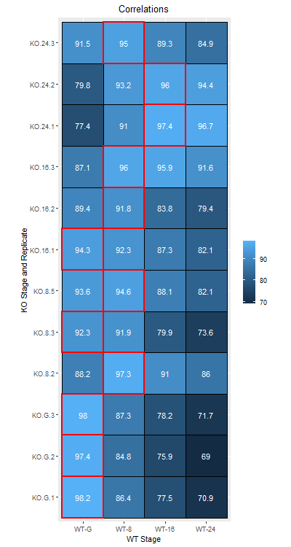

Alternative fig:

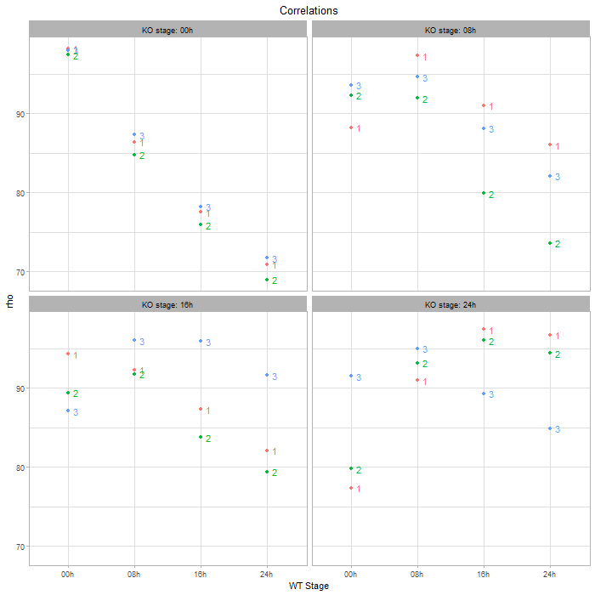

**Single Cell Atlas Context**

Data from a single cell atlas provides a context for our data to be compared with, as visualized by UMAP and PCA. Where UMAP can represent a large amount of information simultaneously PCA can be more useful for pinning down which genes are involved and which cells our KO are behaving like, as the dimensions have a clearly interpretable meaning. Loadings from the PCs representing interesting patterns can be described by groups of genes which can be investigated or summarized with statistical robustness by bioinformatic methods.

The data were analysed in Seurat in a similar protocol to the cell atlas data, log-normalizing cells from the same parts of the cell cycle together and integrating them together for downstream analysis. However due to the low number of bulk cells available keeping them as a separate group for the integration step was not possible, so they were included with the atlas data, in each of their respective (gametocyte and ookinete) groups.

The ookinetes (including healthy ookinetes) do not map closely at all to the ookinetes from the cell atlas and the gametocytes are similar to the female atlas cells. There is however a strong distinction between gametocyte and ookinete samples in the data and subgroups of cell type and time point appear to cluster together. The overlapping boundaries of the cell types suggests that the data has been somewhat skewed by the process of trying to integrate.

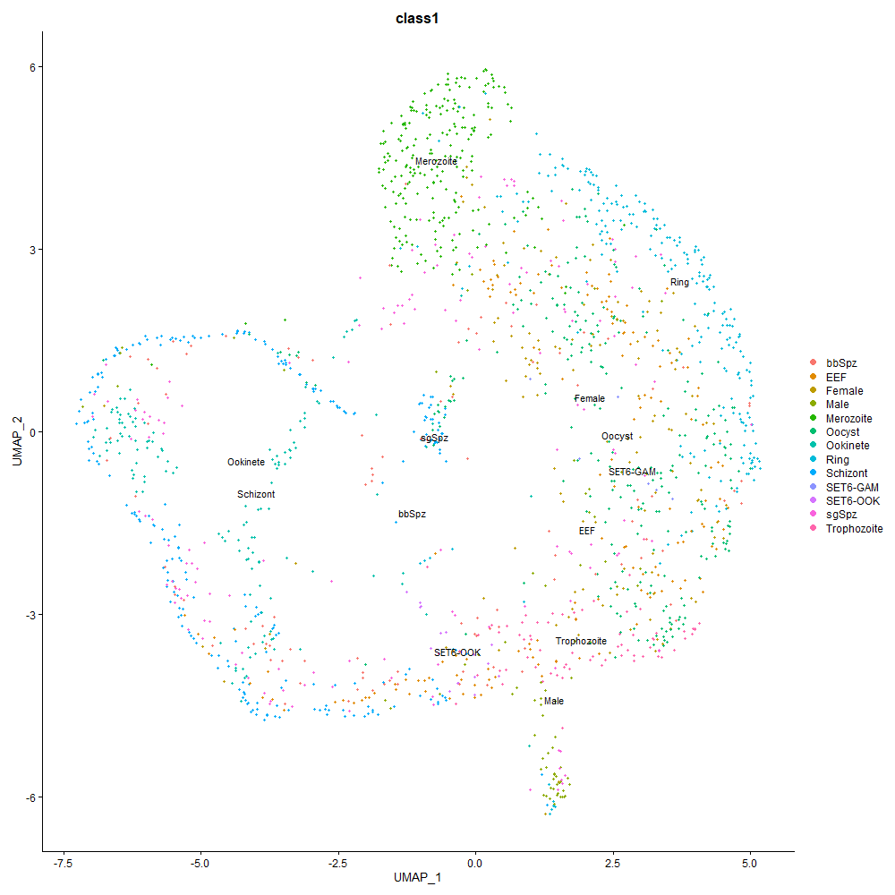

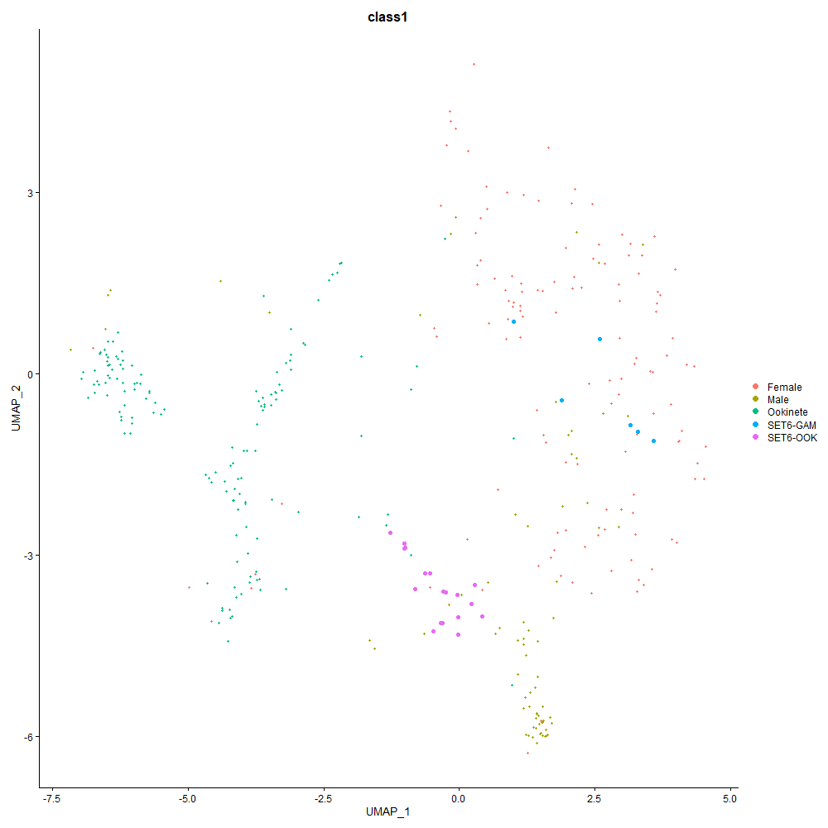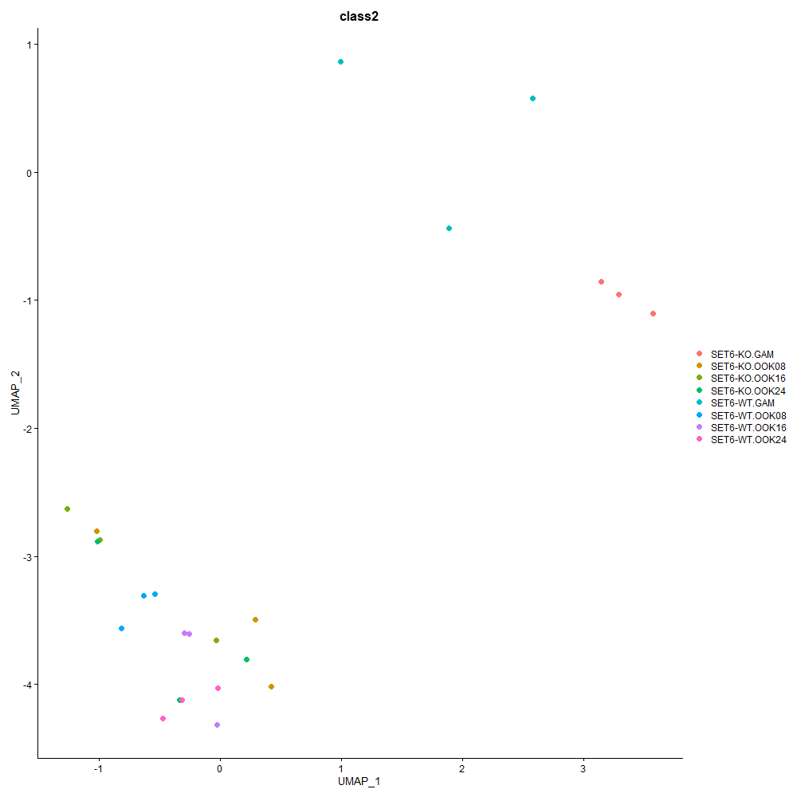

Another two options were investigated – normalizing all of the data together, and normalizing together but with only the relevant cell stages and one stage to either side of them in the cell cycle. With the full dataset similarities might be drawn with more distantly related cells but the smaller set may be easier to work with and more concise. Compared to the other normalization approach the cell groups are much more distinct between-groups, clustering tightly within-group. Figures are larger than presented here for a detailed zoomable view.

Below are some more UMAP images from that analysis and some PCA plots (for each pair four PCA plots were included, using different colours to split the bulk samples by KO/WT and gam/ook, by subgroups of WT/KO and stage and finally showing only the bulk samples.

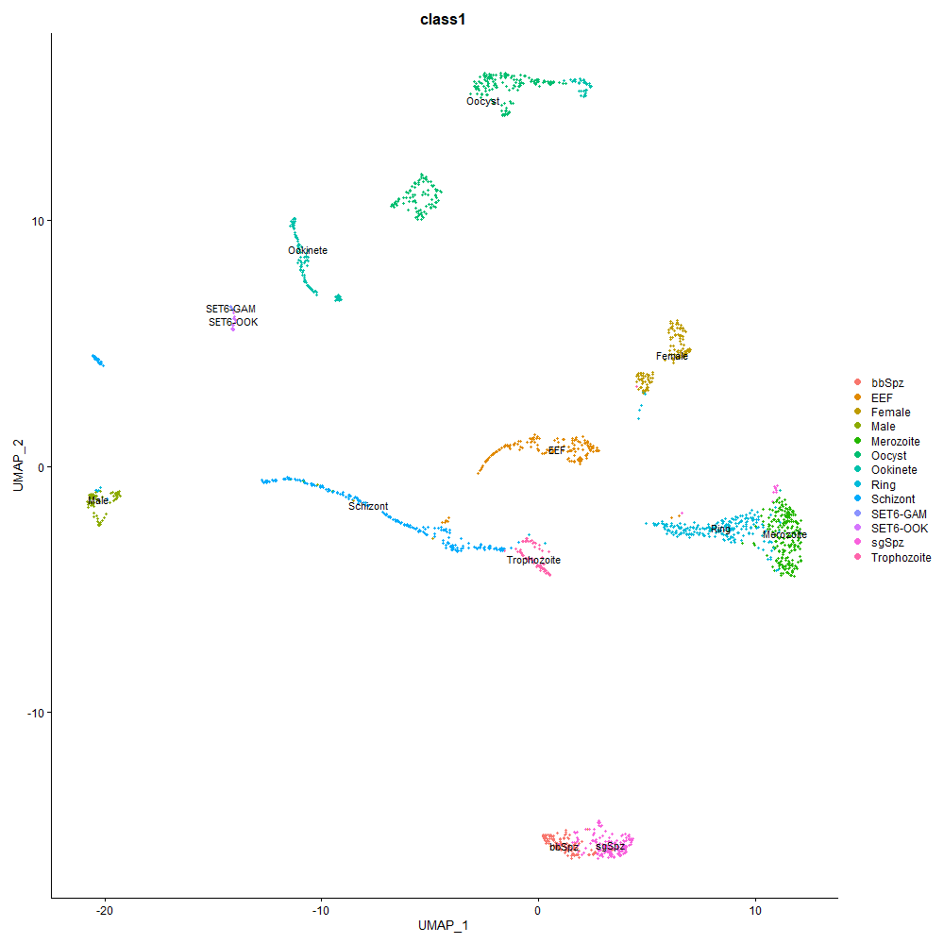

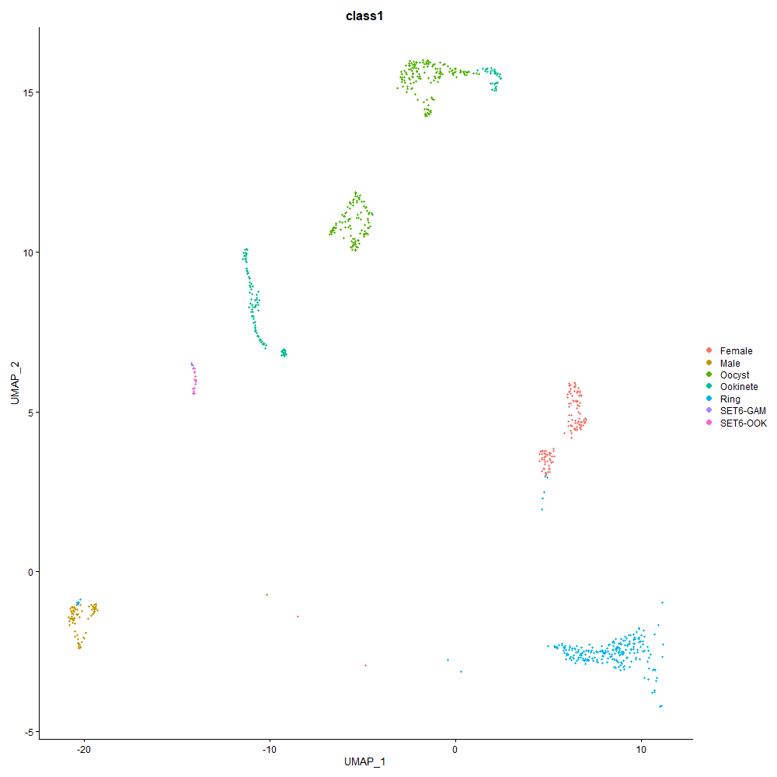

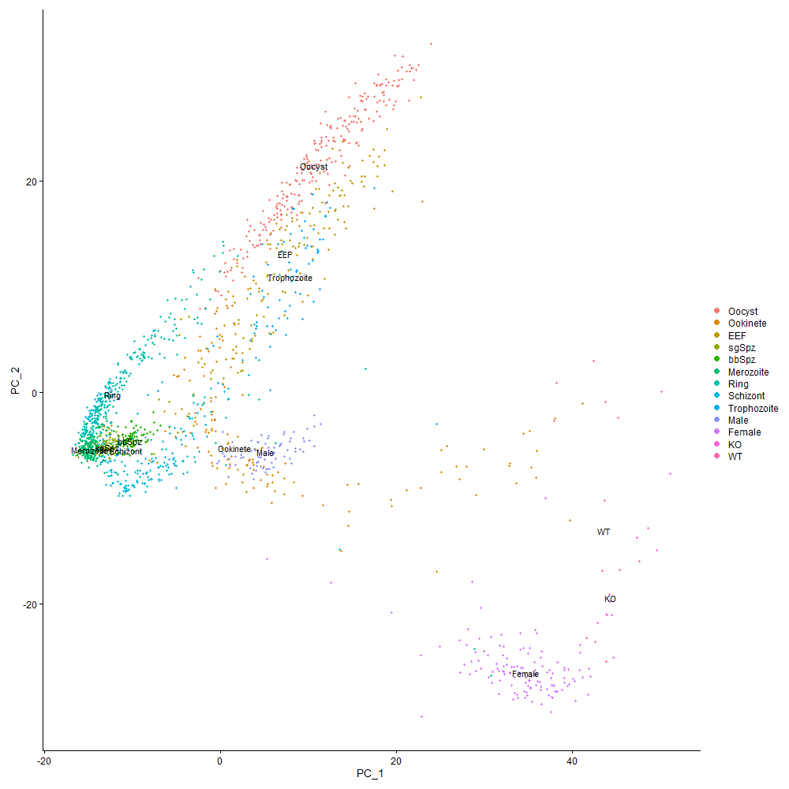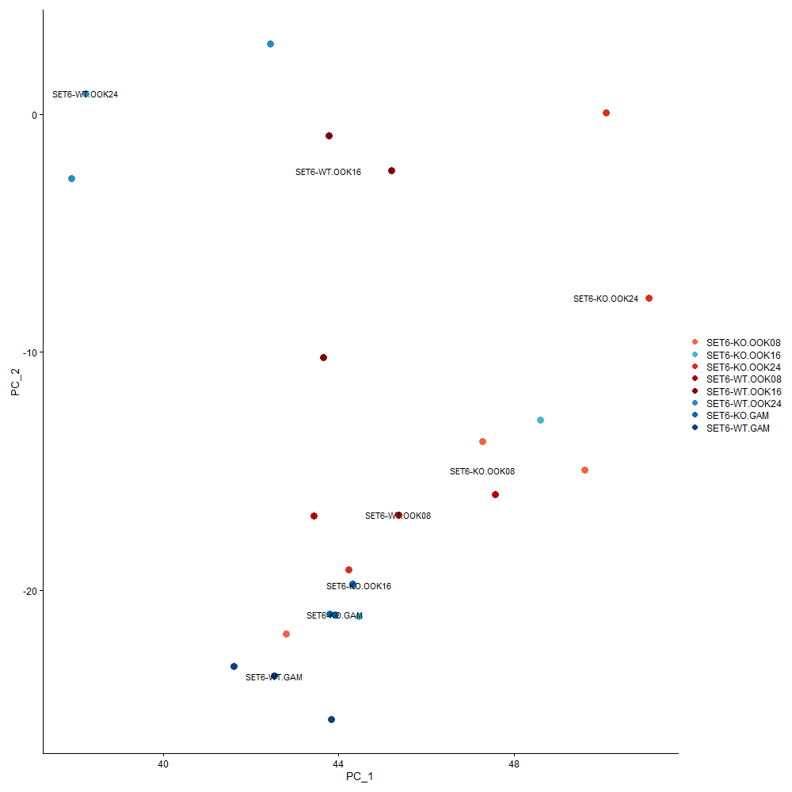

And the small restricted set, showing only the relevant gametocyte, ookinetes, and the developmentally-proximate ring trophozoites and oocysts:

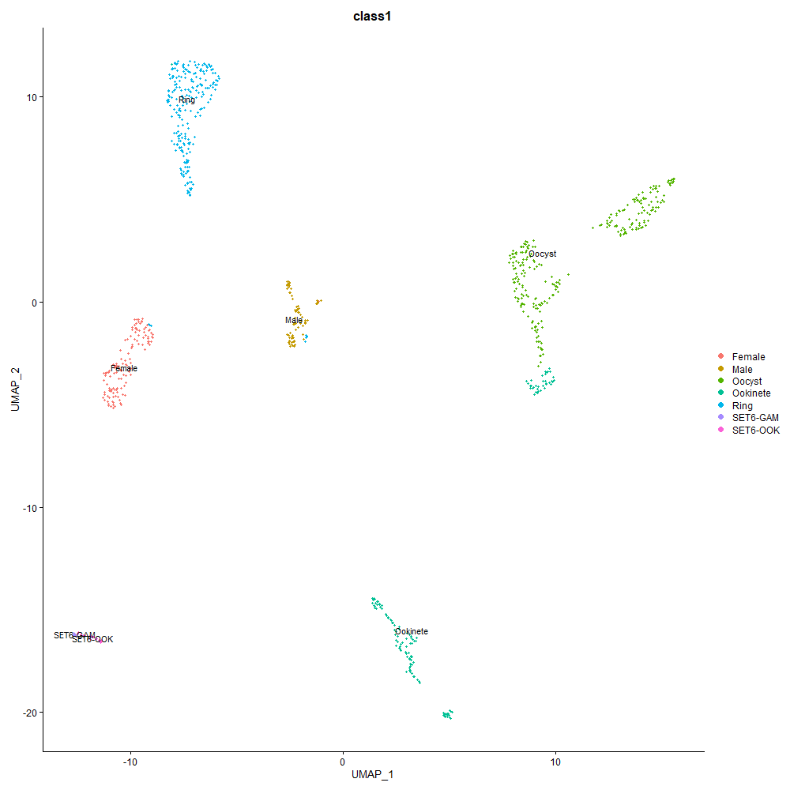

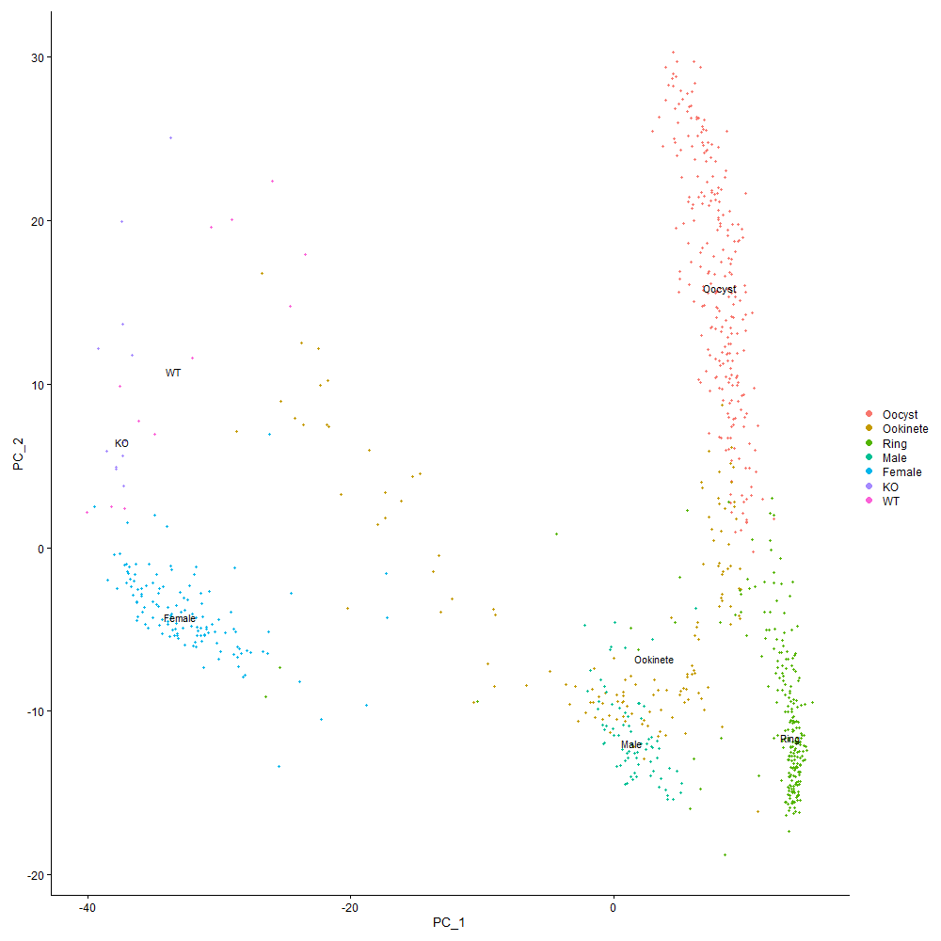

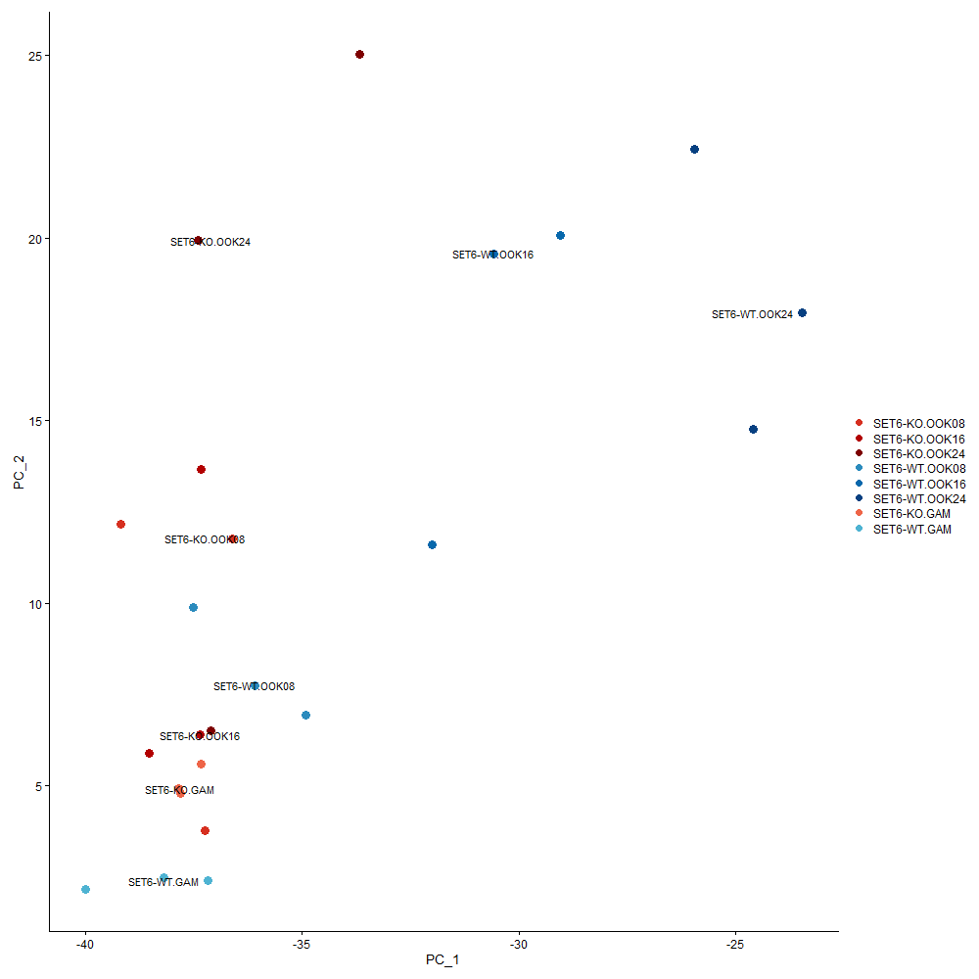

**Differential Expression, Gene Ontology, Pathway Mapping**

Differential expression data (found in ‘**diffExp.xlsx**’) was generated for each possible combination of a WT group and a KO group. These did not show any statistical significance due to low sample numbers, however other contrasts did show significant differential expression when comparing e.g. a KO group against all WT, or all KO ookinetes against all WT ookinetes.

Gene ontology and pathway mapping could be useful for interpreting (i) the differential expression data, (ii) the first PCA analysis, i.e. which genes are most strongly related with PC1 (along which gam-ook development would appear to occur) (iii) and the PCA which includes atlas data for context. The plasmodb.org site has an interface for gene ontology, which I tried for the PC1 loadings, significant output shown below. The loadings over 0.9 didn’t have any significant results after test correction but those under -0.9 did. Or for other gene ontology tools, try using the definitions found here: <https://plasmodb.org/plasmo/app/downloads/release-57/PbergheiANKA/gaf/>

|  |  |  |  |  |  |  |  |  |  |
| --- | --- | --- | --- | --- | --- | --- | --- | --- | --- |
| **Biological Process** | |  |  |  |  |  |  |  |  |
|  | **GO Term** | **Genes in the bkgd with this term** | **Genes in your result with this term** | **Percent of bkgd genes in your result** | **Fold enrichment** | **Odds ratio** | **P-value** | **Benjamini** | **Bonferroni** |
| **GO ID** |
| [GO:0008150](http://amigo.geneontology.org/amigo/term/GO:0008150#display-lineage-tab) | biological process | 179 | [32](https://plasmodb.org/a/app/search/transcript/GeneByLocusTag?param.ds_gene_ids.idList=PBANKA_0501300,PBANKA_0611600,PBANKA_0803100,PBANKA_0818000,PBANKA_0830200,PBANKA_0836300,PBANKA_0910300,PBANKA_0918600,PBANKA_0931200,PBANKA_0932000,PBANKA_0935000,PBANKA_1002100,PBANKA_1030100,PBANKA_1037500,PBANKA_1109400,PBANKA_1127200,PBANKA_1129100,PBANKA_1232200,PBANKA_1303900,PBANKA_1305300,PBANKA_1315700,PBANKA_1319500,PBANKA_1326800,PBANKA_1326900,PBANKA_1329100,PBANKA_1333700,PBANKA_1359700,PBANKA_1402500,PBANKA_1404000,PBANKA_1448900,PBANKA_1455100,PBANKA_1457200,&autoRun=1) | 17.9 | 2.64 | 3.3 | 1.81E-07 | 8.69E-05 | 8.69E-05 |
| [GO:0071103](http://amigo.geneontology.org/amigo/term/GO:0071103#display-lineage-tab) | DNA conformation change | 32 | [10](https://plasmodb.org/a/app/search/transcript/GeneByLocusTag?param.ds_gene_ids.idList=PBANKA_0520500,PBANKA_0803100,PBANKA_0818000,PBANKA_1011400,PBANKA_1024900,PBANKA_1101500,PBANKA_1110100,PBANKA_1360000,PBANKA_1402500,PBANKA_1454000,&autoRun=1) | 31.3 | 4.62 | 6.49 | 2.85E-05 | 6.85E-03 | 1.37E-02 |
| [GO:0006260](http://amigo.geneontology.org/amigo/term/GO:0006260#display-lineage-tab) | DNA replication | 43 | [11](https://plasmodb.org/a/app/search/transcript/GeneByLocusTag?param.ds_gene_ids.idList=PBANKA_0501300,PBANKA_0611600,PBANKA_0803100,PBANKA_0935000,PBANKA_1129100,PBANKA_1232200,PBANKA_1305300,PBANKA_1326800,PBANKA_1326900,PBANKA_1448900,PBANKA_1455100,&autoRun=1) | 25.6 | 3.78 | 4.91 | 8.93E-05 | 1.16E-02 | 4.30E-02 |
| [GO:0006265](http://amigo.geneontology.org/amigo/term/GO:0006265#display-lineage-tab) | DNA topological change | 5 | [4](https://plasmodb.org/a/app/search/transcript/GeneByLocusTag?param.ds_gene_ids.idList=PBANKA_1011400,PBANKA_1110100,PBANKA_1360000,PBANKA_1454000,&autoRun=1) | 80 | 11.83 | 56.05 | 9.67E-05 | 1.16E-02 | 4.65E-02 |
| [GO:0006665](http://amigo.geneontology.org/amigo/term/GO:0006665#display-lineage-tab) | sphingolipid metabolic process | 3 | [3](https://plasmodb.org/a/app/search/transcript/GeneByLocusTag?param.ds_gene_ids.idList=PBANKA_1027000,PBANKA_1123900,PBANKA_1124000,&autoRun=1) | 100 | 14.79 | Infinity | 3.06E-04 | 2.45E-02 | 1.47E-01 |
| [GO:0010468](http://amigo.geneontology.org/amigo/term/GO:0010468#display-lineage-tab) | regulation of gene expression | 3 | [3](https://plasmodb.org/a/app/search/transcript/GeneByLocusTag?param.ds_gene_ids.idList=PBANKA_0109700,PBANKA_1206200,PBANKA_1449300,&autoRun=1) | 100 | 14.79 | Infinity | 3.06E-04 | 2.45E-02 |  |
| **Cellular Component** | |  |  |  |  |  |  |  |  |
|  | **Genes in the bkgd with this term** | **Genes in your result with this term** | **Percent of bkgd genes in your result** | **Fold enrichment** | **Odds ratio** | **P-value** | **Benjamini** | **Bonferroni** |  |
| **GO Term** |  |
| [GO:0044312](http://amigo.geneontology.org/amigo/term/GO:0044312#display-lineage-tab) | crystalloid | 17 | [7](https://plasmodb.org/a/app/search/transcript/GeneByLocusTag?param.ds_gene_ids.idList=PBANKA_0204500,PBANKA_0417600,PBANKA_1104100,PBANKA_1300700,PBANKA_1315300,PBANKA_1317200,PBANKA_1319500,&autoRun=1) | 41.2 | 6.09 | 9.9 | 6.42E-05 | 1.10E-02 | 1.10E-02 |
| **Molecular Function** | |  |  |  |  |  |  |  |  |
|  | **GO Term** | **Genes in the bkgd with this term** | **Genes in your result with this term** | **Percent of bkgd genes in your result** | **Fold enrichment** | **Odds ratio** | **P-value** | **Benjamini** | **Bonferroni** |
| **GO ID** |
| [GO:0000166](http://amigo.geneontology.org/amigo/term/GO:0000166#display-lineage-tab) | nucleotide binding | 522 | [61](https://plasmodb.org/a/app/search/transcript/GeneByLocusTag?param.ds_gene_ids.idList=PBANKA_0312700,PBANKA_0501300,PBANKA_0507300,PBANKA_0518700,PBANKA_0520500,PBANKA_0600600,PBANKA_0606100,PBANKA_0608300,PBANKA_0611600,PBANKA_0615800,PBANKA_0714200,PBANKA_0803100,PBANKA_0804300,PBANKA_0805900,PBANKA_0806300,PBANKA_0821700,PBANKA_0823100,PBANKA_0901900,PBANKA_0902400,PBANKA_0908500,PBANKA_0910300,PBANKA_0924900,PBANKA_0925400,PBANKA_0926400,PBANKA_0931200,PBANKA_0934100,PBANKA_0942900,PBANKA_1008100,PBANKA_1008300,PBANKA_1011400,PBANKA_1019800,PBANKA_1024900,PBANKA_1026600,PBANKA_1030100,PBANKA_1033600,PBANKA_1035600,PBANKA_1105100,PBANKA_1109200,PBANKA_1124500,PBANKA_1125500,PBANKA_1127500,PBANKA_1129100,PBANKA_1133100,PBANKA_1202200,PBANKA_1203700,PBANKA_1218200,PBANKA_1224100,PBANKA_1226600,PBANKA_1237800,PBANKA_1300500,PBANKA_1301500,PBANKA_1305200,PBANKA_1317200,PBANKA_1326800,PBANKA_1329200,PBANKA_1356400,PBANKA_1414500,PBANKA_1434100,PBANKA_1434800,PBANKA_1454000,PBANKA_1455100,&autoRun=1) | 11.7 | 1.73 | 2.09 | 4.77E-06 | 4.74E-04 | 1.21E-03 |
| [GO:1901265](http://amigo.geneontology.org/amigo/term/GO:1901265#display-lineage-tab) | nucleoside phosphate binding | 522 | [61](https://plasmodb.org/a/app/search/transcript/GeneByLocusTag?param.ds_gene_ids.idList=PBANKA_0312700,PBANKA_0501300,PBANKA_0507300,PBANKA_0518700,PBANKA_0520500,PBANKA_0600600,PBANKA_0606100,PBANKA_0608300,PBANKA_0611600,PBANKA_0615800,PBANKA_0714200,PBANKA_0803100,PBANKA_0804300,PBANKA_0805900,PBANKA_0806300,PBANKA_0821700,PBANKA_0823100,PBANKA_0901900,PBANKA_0902400,PBANKA_0908500,PBANKA_0910300,PBANKA_0924900,PBANKA_0925400,PBANKA_0926400,PBANKA_0931200,PBANKA_0934100,PBANKA_0942900,PBANKA_1008100,PBANKA_1008300,PBANKA_1011400,PBANKA_1019800,PBANKA_1024900,PBANKA_1026600,PBANKA_1030100,PBANKA_1033600,PBANKA_1035600,PBANKA_1105100,PBANKA_1109200,PBANKA_1124500,PBANKA_1125500,PBANKA_1127500,PBANKA_1129100,PBANKA_1133100,PBANKA_1202200,PBANKA_1203700,PBANKA_1218200,PBANKA_1224100,PBANKA_1226600,PBANKA_1237800,PBANKA_1300500,PBANKA_1301500,PBANKA_1305200,PBANKA_1317200,PBANKA_1326800,PBANKA_1329200,PBANKA_1356400,PBANKA_1414500,PBANKA_1434100,PBANKA_1434800,PBANKA_1454000,PBANKA_1455100,&autoRun=1) | 11.7 | 1.73 | 2.09 | 4.77E-06 | 4.74E-04 | 1.21E-03 |
| [GO:0035639](http://amigo.geneontology.org/amigo/term/GO:0035639#display-lineage-tab) | purine ribonucleoside triphosphate binding | 471 | [56](https://plasmodb.org/a/app/search/transcript/GeneByLocusTag?param.ds_gene_ids.idList=PBANKA_0312700,PBANKA_0507300,PBANKA_0518700,PBANKA_0520500,PBANKA_0600600,PBANKA_0606100,PBANKA_0608300,PBANKA_0611600,PBANKA_0615800,PBANKA_0714200,PBANKA_0803100,PBANKA_0804300,PBANKA_0805900,PBANKA_0806300,PBANKA_0823100,PBANKA_0901900,PBANKA_0902400,PBANKA_0908500,PBANKA_0910300,PBANKA_0924900,PBANKA_0925400,PBANKA_0926400,PBANKA_0931200,PBANKA_0934100,PBANKA_0942900,PBANKA_1008100,PBANKA_1008300,PBANKA_1011400,PBANKA_1019800,PBANKA_1024900,PBANKA_1026600,PBANKA_1030100,PBANKA_1035600,PBANKA_1105100,PBANKA_1109200,PBANKA_1124500,PBANKA_1125500,PBANKA_1127500,PBANKA_1133100,PBANKA_1202200,PBANKA_1203700,PBANKA_1218200,PBANKA_1224100,PBANKA_1226600,PBANKA_1237800,PBANKA_1300500,PBANKA_1301500,PBANKA_1305200,PBANKA_1326800,PBANKA_1329200,PBANKA_1356400,PBANKA_1414500,PBANKA_1434100,PBANKA_1434800,PBANKA_1454000,PBANKA_1455100,&autoRun=1) | 11.9 | 1.76 | 2.11 | 7.73E-06 | 4.74E-04 | 1.96E-03 |
| [GO:0032555](http://amigo.geneontology.org/amigo/term/GO:0032555#display-lineage-tab) | purine ribonucleotide binding | 476 | [56](https://plasmodb.org/a/app/search/transcript/GeneByLocusTag?param.ds_gene_ids.idList=PBANKA_0312700,PBANKA_0507300,PBANKA_0518700,PBANKA_0520500,PBANKA_0600600,PBANKA_0606100,PBANKA_0608300,PBANKA_0611600,PBANKA_0615800,PBANKA_0714200,PBANKA_0803100,PBANKA_0804300,PBANKA_0805900,PBANKA_0806300,PBANKA_0823100,PBANKA_0901900,PBANKA_0902400,PBANKA_0908500,PBANKA_0910300,PBANKA_0924900,PBANKA_0925400,PBANKA_0926400,PBANKA_0931200,PBANKA_0934100,PBANKA_0942900,PBANKA_1008100,PBANKA_1008300,PBANKA_1011400,PBANKA_1019800,PBANKA_1024900,PBANKA_1026600,PBANKA_1030100,PBANKA_1035600,PBANKA_1105100,PBANKA_1109200,PBANKA_1124500,PBANKA_1125500,PBANKA_1127500,PBANKA_1133100,PBANKA_1202200,PBANKA_1203700,PBANKA_1218200,PBANKA_1224100,PBANKA_1226600,PBANKA_1237800,PBANKA_1300500,PBANKA_1301500,PBANKA_1305200,PBANKA_1326800,PBANKA_1329200,PBANKA_1356400,PBANKA_1414500,PBANKA_1434100,PBANKA_1434800,PBANKA_1454000,PBANKA_1455100,&autoRun=1) | 11.8 | 1.74 | 2.08 | 1.08E-05 | 4.74E-04 | 2.73E-03 |
| [GO:0017076](http://amigo.geneontology.org/amigo/term/GO:0017076#display-lineage-tab) | purine nucleotide binding | 477 | [56](https://plasmodb.org/a/app/search/transcript/GeneByLocusTag?param.ds_gene_ids.idList=PBANKA_0312700,PBANKA_0507300,PBANKA_0518700,PBANKA_0520500,PBANKA_0600600,PBANKA_0606100,PBANKA_0608300,PBANKA_0611600,PBANKA_0615800,PBANKA_0714200,PBANKA_0803100,PBANKA_0804300,PBANKA_0805900,PBANKA_0806300,PBANKA_0823100,PBANKA_0901900,PBANKA_0902400,PBANKA_0908500,PBANKA_0910300,PBANKA_0924900,PBANKA_0925400,PBANKA_0926400,PBANKA_0931200,PBANKA_0934100,PBANKA_0942900,PBANKA_1008100,PBANKA_1008300,PBANKA_1011400,PBANKA_1019800,PBANKA_1024900,PBANKA_1026600,PBANKA_1030100,PBANKA_1035600,PBANKA_1105100,PBANKA_1109200,PBANKA_1124500,PBANKA_1125500,PBANKA_1127500,PBANKA_1133100,PBANKA_1202200,PBANKA_1203700,PBANKA_1218200,PBANKA_1224100,PBANKA_1226600,PBANKA_1237800,PBANKA_1300500,PBANKA_1301500,PBANKA_1305200,PBANKA_1326800,PBANKA_1329200,PBANKA_1356400,PBANKA_1414500,PBANKA_1434100,PBANKA_1434800,PBANKA_1454000,PBANKA_1455100,&autoRun=1) | 11.7 | 1.74 | 2.08 | 1.15E-05 | 4.74E-04 | 2.92E-03 |
| [GO:0043168](http://amigo.geneontology.org/amigo/term/GO:0043168#display-lineage-tab) | anion binding | 502 | [58](https://plasmodb.org/a/app/search/transcript/GeneByLocusTag?param.ds_gene_ids.idList=PBANKA_0312700,PBANKA_0507300,PBANKA_0518700,PBANKA_0520500,PBANKA_0600600,PBANKA_0606100,PBANKA_0608300,PBANKA_0611600,PBANKA_0615800,PBANKA_0714200,PBANKA_0803100,PBANKA_0804300,PBANKA_0805900,PBANKA_0806300,PBANKA_0823100,PBANKA_0901900,PBANKA_0902400,PBANKA_0908500,PBANKA_0910300,PBANKA_0924900,PBANKA_0925400,PBANKA_0926400,PBANKA_0931200,PBANKA_0934100,PBANKA_0942900,PBANKA_1008100,PBANKA_1008300,PBANKA_1011400,PBANKA_1019800,PBANKA_1024900,PBANKA_1026600,PBANKA_1027000,PBANKA_1030100,PBANKA_1033600,PBANKA_1035600,PBANKA_1105100,PBANKA_1109200,PBANKA_1124500,PBANKA_1125500,PBANKA_1127500,PBANKA_1133100,PBANKA_1202200,PBANKA_1203700,PBANKA_1218200,PBANKA_1224100,PBANKA_1226600,PBANKA_1237800,PBANKA_1300500,PBANKA_1301500,PBANKA_1305200,PBANKA_1326800,PBANKA_1329200,PBANKA_1356400,PBANKA_1414500,PBANKA_1434100,PBANKA_1434800,PBANKA_1454000,PBANKA_1455100,&autoRun=1) | 11.6 | 1.71 | 2.05 | 1.27E-05 | 4.74E-04 | 3.22E-03 |
| [GO:0032553](http://amigo.geneontology.org/amigo/term/GO:0032553#display-lineage-tab) | ribonucleotide binding | 479 | [56](https://plasmodb.org/a/app/search/transcript/GeneByLocusTag?param.ds_gene_ids.idList=PBANKA_0312700,PBANKA_0507300,PBANKA_0518700,PBANKA_0520500,PBANKA_0600600,PBANKA_0606100,PBANKA_0608300,PBANKA_0611600,PBANKA_0615800,PBANKA_0714200,PBANKA_0803100,PBANKA_0804300,PBANKA_0805900,PBANKA_0806300,PBANKA_0823100,PBANKA_0901900,PBANKA_0902400,PBANKA_0908500,PBANKA_0910300,PBANKA_0924900,PBANKA_0925400,PBANKA_0926400,PBANKA_0931200,PBANKA_0934100,PBANKA_0942900,PBANKA_1008100,PBANKA_1008300,PBANKA_1011400,PBANKA_1019800,PBANKA_1024900,PBANKA_1026600,PBANKA_1030100,PBANKA_1035600,PBANKA_1105100,PBANKA_1109200,PBANKA_1124500,PBANKA_1125500,PBANKA_1127500,PBANKA_1133100,PBANKA_1202200,PBANKA_1203700,PBANKA_1218200,PBANKA_1224100,PBANKA_1226600,PBANKA_1237800,PBANKA_1300500,PBANKA_1301500,PBANKA_1305200,PBANKA_1326800,PBANKA_1329200,PBANKA_1356400,PBANKA_1414500,PBANKA_1434100,PBANKA_1434800,PBANKA_1454000,PBANKA_1455100,&autoRun=1) | 11.7 | 1.73 | 2.07 | 1.31E-05 | 4.74E-04 | 3.32E-03 |
| [GO:0005524](http://amigo.geneontology.org/amigo/term/GO:0005524#display-lineage-tab) | ATP binding | 388 | [47](https://plasmodb.org/a/app/search/transcript/GeneByLocusTag?param.ds_gene_ids.idList=PBANKA_0312700,PBANKA_0507300,PBANKA_0518700,PBANKA_0520500,PBANKA_0600600,PBANKA_0606100,PBANKA_0608300,PBANKA_0611600,PBANKA_0615800,PBANKA_0714200,PBANKA_0803100,PBANKA_0804300,PBANKA_0805900,PBANKA_0806300,PBANKA_0823100,PBANKA_0901900,PBANKA_0902400,PBANKA_0908500,PBANKA_0910300,PBANKA_0925400,PBANKA_0926400,PBANKA_0931200,PBANKA_0942900,PBANKA_1011400,PBANKA_1019800,PBANKA_1024900,PBANKA_1030100,PBANKA_1035600,PBANKA_1105100,PBANKA_1109200,PBANKA_1124500,PBANKA_1125500,PBANKA_1127500,PBANKA_1133100,PBANKA_1203700,PBANKA_1218200,PBANKA_1224100,PBANKA_1237800,PBANKA_1301500,PBANKA_1305200,PBANKA_1326800,PBANKA_1329200,PBANKA_1356400,PBANKA_1414500,PBANKA_1434800,PBANKA_1454000,PBANKA_1455100,&autoRun=1) | 12.1 | 1.79 | 2.11 | 3.05E-05 | 9.68E-04 | 7.75E-03 |
| [GO:0032559](http://amigo.geneontology.org/amigo/term/GO:0032559#display-lineage-tab) | adenyl ribonucleotide binding | 392 | [47](https://plasmodb.org/a/app/search/transcript/GeneByLocusTag?param.ds_gene_ids.idList=PBANKA_0312700,PBANKA_0507300,PBANKA_0518700,PBANKA_0520500,PBANKA_0600600,PBANKA_0606100,PBANKA_0608300,PBANKA_0611600,PBANKA_0615800,PBANKA_0714200,PBANKA_0803100,PBANKA_0804300,PBANKA_0805900,PBANKA_0806300,PBANKA_0823100,PBANKA_0901900,PBANKA_0902400,PBANKA_0908500,PBANKA_0910300,PBANKA_0925400,PBANKA_0926400,PBANKA_0931200,PBANKA_0942900,PBANKA_1011400,PBANKA_1019800,PBANKA_1024900,PBANKA_1030100,PBANKA_1035600,PBANKA_1105100,PBANKA_1109200,PBANKA_1124500,PBANKA_1125500,PBANKA_1127500,PBANKA_1133100,PBANKA_1203700,PBANKA_1218200,PBANKA_1224100,PBANKA_1237800,PBANKA_1301500,PBANKA_1305200,PBANKA_1326800,PBANKA_1329200,PBANKA_1356400,PBANKA_1414500,PBANKA_1434800,PBANKA_1454000,PBANKA_1455100,&autoRun=1) | 12 | 1.77 | 2.08 | 4.00E-05 | 1.09E-03 | 1.02E-02 |
| [GO:0030554](http://amigo.geneontology.org/amigo/term/GO:0030554#display-lineage-tab) | adenyl nucleotide binding | 393 | [47](https://plasmodb.org/a/app/search/transcript/GeneByLocusTag?param.ds_gene_ids.idList=PBANKA_0312700,PBANKA_0507300,PBANKA_0518700,PBANKA_0520500,PBANKA_0600600,PBANKA_0606100,PBANKA_0608300,PBANKA_0611600,PBANKA_0615800,PBANKA_0714200,PBANKA_0803100,PBANKA_0804300,PBANKA_0805900,PBANKA_0806300,PBANKA_0823100,PBANKA_0901900,PBANKA_0902400,PBANKA_0908500,PBANKA_0910300,PBANKA_0925400,PBANKA_0926400,PBANKA_0931200,PBANKA_0942900,PBANKA_1011400,PBANKA_1019800,PBANKA_1024900,PBANKA_1030100,PBANKA_1035600,PBANKA_1105100,PBANKA_1109200,PBANKA_1124500,PBANKA_1125500,PBANKA_1127500,PBANKA_1133100,PBANKA_1203700,PBANKA_1218200,PBANKA_1224100,PBANKA_1237800,PBANKA_1301500,PBANKA_1305200,PBANKA_1326800,PBANKA_1329200,PBANKA_1356400,PBANKA_1414500,PBANKA_1434800,PBANKA_1454000,PBANKA_1455100,&autoRun=1) | 12 | 1.77 | 2.08 | 4.27E-05 | 1.09E-03 | 1.09E-02 |
| [GO:0003916](http://amigo.geneontology.org/amigo/term/GO:0003916#display-lineage-tab) | DNA topoisomerase activity | 5 | [4](https://plasmodb.org/a/app/search/transcript/GeneByLocusTag?param.ds_gene_ids.idList=PBANKA_1011400,PBANKA_1110100,PBANKA_1360000,PBANKA_1454000,&autoRun=1) | 80 | 11.83 | 56.05 | 9.67E-05 | 2.23E-03 | 2.46E-02 |
| [GO:0140657](http://amigo.geneontology.org/amigo/term/GO:0140657#display-lineage-tab) | ATP-dependent activity | 178 | [26](https://plasmodb.org/a/app/search/transcript/GeneByLocusTag?param.ds_gene_ids.idList=PBANKA_0312700,PBANKA_0507300,PBANKA_0520500,PBANKA_0608300,PBANKA_0714200,PBANKA_0803100,PBANKA_0805900,PBANKA_0806300,PBANKA_0902400,PBANKA_0910300,PBANKA_0925400,PBANKA_0931200,PBANKA_1011400,PBANKA_1024900,PBANKA_1035600,PBANKA_1125500,PBANKA_1203700,PBANKA_1224100,PBANKA_1237800,PBANKA_1301000,PBANKA_1326800,PBANKA_1329200,PBANKA_1401000,PBANKA_1434800,PBANKA_1454000,PBANKA_1455100,&autoRun=1) | 14.6 | 2.16 | 2.52 | 1.15E-04 | 2.43E-03 | 2.92E-02 |
| [GO:0003777](http://amigo.geneontology.org/amigo/term/GO:0003777#display-lineage-tab) | microtubule motor activity | 18 | [6](https://plasmodb.org/a/app/search/transcript/GeneByLocusTag?param.ds_gene_ids.idList=PBANKA_0507300,PBANKA_0805900,PBANKA_0902400,PBANKA_0925400,PBANKA_1224100,PBANKA_1329200,&autoRun=1) | 33.3 | 4.93 | 7.04 | 8.36E-04 | 1.63E-02 | 2.12E-01 |
| [GO:0003887](http://amigo.geneontology.org/amigo/term/GO:0003887#display-lineage-tab) | DNA-directed DNA polymerase activity | 8 | [4](https://plasmodb.org/a/app/search/transcript/GeneByLocusTag?param.ds_gene_ids.idList=PBANKA_0501300,PBANKA_1129100,PBANKA_1326900,PBANKA_1448900,&autoRun=1) | 50 | 7.4 | 14 | 1.15E-03 | 1.97E-02 | 2.92E-01 |
| [GO:0140326](http://amigo.geneontology.org/amigo/term/GO:0140326#display-lineage-tab) | ATPase-coupled intramembrane lipid transporter activity | 4 | [3](https://plasmodb.org/a/app/search/transcript/GeneByLocusTag?param.ds_gene_ids.idList=PBANKA_0806300,PBANKA_0910300,PBANKA_1434800,&autoRun=1) | 75 | 11.09 | 41.87 | 1.16E-03 | 1.97E-02 | 2.95E-01 |
| [GO:0043167](http://amigo.geneontology.org/amigo/term/GO:0043167#display-lineage-tab) | ion binding | 751 | 70 | 9.3 | 1.38 | 1.58 | 1.57E-03 | 2.36E-02 | 3.98E-01 |
| [GO:0008092](http://amigo.geneontology.org/amigo/term/GO:0008092#display-lineage-tab) | cytoskeletal protein binding | 42 | [9](https://plasmodb.org/a/app/search/transcript/GeneByLocusTag?param.ds_gene_ids.idList=PBANKA_0805900,PBANKA_0902400,PBANKA_0908500,PBANKA_1137800,PBANKA_1224100,PBANKA_1333300,PBANKA_1336500,PBANKA_1434600,PBANKA_1455800,&autoRun=1) | 21.4 | 3.17 | 3.86 | 1.58E-03 | 2.36E-02 | 4.01E-01 |
| [GO:0017111](http://amigo.geneontology.org/amigo/term/GO:0017111#display-lineage-tab) | nucleoside-triphosphatase activity | 130 | [18](https://plasmodb.org/a/app/search/transcript/GeneByLocusTag?param.ds_gene_ids.idList=PBANKA_0507300,PBANKA_0520500,PBANKA_0714200,PBANKA_0805900,PBANKA_0924900,PBANKA_0925400,PBANKA_0931200,PBANKA_1026600,PBANKA_1035600,PBANKA_1125500,PBANKA_1202200,PBANKA_1226600,PBANKA_1237800,PBANKA_1300500,PBANKA_1326800,PBANKA_1434100,PBANKA_1434800,PBANKA_1455100,&autoRun=1) | 13.8 | 2.05 | 2.31 | 2.48E-03 | 3.50E-02 | 6.30E-01 |
| [GO:0140303](http://amigo.geneontology.org/amigo/term/GO:0140303#display-lineage-tab) | intramembrane lipid transporter activity | 5 | [3](https://plasmodb.org/a/app/search/transcript/GeneByLocusTag?param.ds_gene_ids.idList=PBANKA_0806300,PBANKA_0910300,PBANKA_1434800,&autoRun=1) | 60 | 8.87 | 20.93 | 2.76E-03 | 3.63E-02 | 7.00E-01 |
| [GO:0003774](http://amigo.geneontology.org/amigo/term/GO:0003774#display-lineage-tab) | cytoskeletal motor activity | 30 | [7](https://plasmodb.org/a/app/search/transcript/GeneByLocusTag?param.ds_gene_ids.idList=PBANKA_0507300,PBANKA_0805900,PBANKA_0902400,PBANKA_0908500,PBANKA_0925400,PBANKA_1224100,PBANKA_1329200,&autoRun=1) | 23.3 | 3.45 | 4.29 | 3.14E-03 | 3.63E-02 | 7.98E-01 |
| [GO:0016887](http://amigo.geneontology.org/amigo/term/GO:0016887#display-lineage-tab) | ATP hydrolysis activity | 73 | [12](https://plasmodb.org/a/app/search/transcript/GeneByLocusTag?param.ds_gene_ids.idList=PBANKA_0507300,PBANKA_0520500,PBANKA_0714200,PBANKA_0805900,PBANKA_0925400,PBANKA_0931200,PBANKA_1035600,PBANKA_1125500,PBANKA_1237800,PBANKA_1326800,PBANKA_1434800,PBANKA_1455100,&autoRun=1) | 16.4 | 2.43 | 2.8 | 3.15E-03 | 3.63E-02 | 7.99E-01 |
| [GO:0003677](http://amigo.geneontology.org/amigo/term/GO:0003677#display-lineage-tab) | DNA binding | 154 | [20](https://plasmodb.org/a/app/search/transcript/GeneByLocusTag?param.ds_gene_ids.idList=PBANKA_0406000,PBANKA_0501300,PBANKA_0520500,PBANKA_0803100,PBANKA_0804300,PBANKA_0905900,PBANKA_0935000,PBANKA_1011400,PBANKA_1024900,PBANKA_1034300,PBANKA_1110100,PBANKA_1129100,PBANKA_1203700,PBANKA_1305300,PBANKA_1326800,PBANKA_1326900,PBANKA_1360000,PBANKA_1448900,PBANKA_1454000,PBANKA_1455100,&autoRun=1) | 13 | 1.92 | 2.15 | 3.15E-03 | 3.63E-02 | 8.00E-01 |